Industry & Alumni Collaboration Portal

Live Cloud Production URL: https://wonderful-wave-0320abf00.3.azurestaticapps.net/
Core Stack: Spring Boot 3 (Java 17), Python 3.10 (FastAPI), React 18, Netflix Eureka, RabbitMQ, PostgreSQL

1. High-Level Architectural Overview
The NSBM Industry & Alumni Collaboration Portal architecture strictly decouples client interfaces from backing services through a reactive API Gateway and service discovery registry. Workflows are partitioned into synchronous request-response cycles (for real-time queries and authenticated UI actions) and asynchronous event pipelines.

2. Microservices Topology Diagram
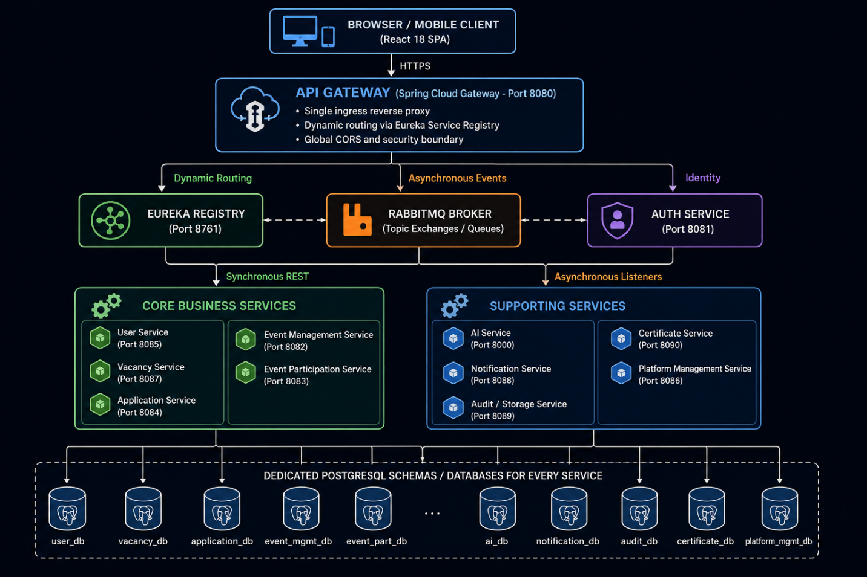

3. End-to-End Operational Workflows

3.1 Student Registration & Profile Setup Flow
Step | Phase | Action & Inter-Service Collaboration
01 | Registration Submission | Student completes the registration form (/register) selecting role STUDENT. Payload routes via API Gateway to Auth Service.
02 | Credential Creation | Auth Service hashes password with BCrypt and creates record in auth_db.
03 | Profile Shell Provisioning | User Service provisions an associated blank student profile shell linked to the newly generated userId.
04 | Authentication | Student logs in via /login. Auth Service verifies credentials and issues a signed 24-hour JWT token.
05 | Academic Portfolio Setup | Student populates degree program, faculty, department, GPA, expected graduation, and skills into user_db.

3.2 AI-Powered Resume Enhancement Flow
Step | Phase | Action & Inter-Service Collaboration
01 | Resume Upload | Student uploads resume PDF in their profile modal. File routes to Audit & Storage Service (POST /api/v1/storage/upload), which returns a unique storageFileId.
02 | Trigger Enhancement | Student clicks "Enhance Profile with AI". User Service dispatches POST /api/v1/ai/resume/enhance-profile.
03 | PDF Parsing & OCR | AI Service streams the PDF from Storage, extracts text via PyMuPDF, and prompts Google Gemini (gemini-3.1-flash-lite).
04 | Structured Skill Extraction | Gemini returns validated technical proficiencies, frameworks, tools, and completed projects formatted as strict JSON.
05 | Profile Enrichment | User Service updates the student's verified skills and project showcases, refreshing the frontend dashboard with AI-verified tags.

3.3 Industry Partner Onboarding & Institutional Accreditation
Step | Phase | Action & Inter-Service Collaboration
01 | Partner Registration | Company representative registers on portal selecting INDUSTRY_PARTNER. Account status defaults to PENDING_VERIFICATION.
02 | Document Submission | Partner uploads business registration certificates and corporate details via Audit & Storage Service.
03 | Staff Audit Queue | University Placement Staff accesses Staff Admin Dashboard (/staff) and reviews pending partner applications.
04 | Verification Approval | Staff verifies corporate legitimacy and clicks "Approve". Platform Management updates partner status to VERIFIED.
05 | Notification Dispatch | Notification Service dispatches an automated branded approval email. The partner is now unlocked to publish job vacancies.

3.4 Vacancy Creation, Flyer OCR & Gemini Processing Flow
Step | Phase | Action & Inter-Service Collaboration
01 | Flyer Upload | Verified partner uploads job advertisement poster (PNG, JPG, or PDF) via Partner Portal (/partner/jobs).
02 | Asset Persistence | Audit & Storage Service stores the binary graphic and returns storageFileId.
03 | Event Emission | Vacancy Service creates a preliminary vacancy in status PENDING and publishes vacancy.flyer.process to RabbitMQ.
04 | Vision OCR & Extraction | AI Service downloads graphic, runs Gemini Vision OCR, and extracts role title, seniority, workplace type, skills, and deadlines.
05 | Anonymous Recruiter Correction | If recruiter provides a generic email (e.g., hrdcareers942@gmail.com), Gemini deduces the authentic enterprise brand name.
06 | Curriculum Alignment | AI compares vacancy requirements against curriculum of all 4 NSBM faculties, scoring syllabus fit and noting anomalies.
07 | Staff Review & Approval | University staff reviews AI recommendations on Staff Dashboard (/staff/vacancies) and clicks "Approve".
08 | Cohort Broadcasting | Vacancy transitions to APPROVED. Notification Service transmits alert emails to students in matching faculties.

3.5 Job Application & AI Semantic Match Scoring Flow
Step | Phase | Action & Inter-Service Collaboration
01 | Vacancy Selection | Student navigates to job details and clicks "Apply".
02 | AI Cover Letter Synthesis | (Optional) Student clicks "Generate AI Cover Letter". AI Service matches student profile against job requirements and synthesizes a tailored cover letter.
03 | Application Submission | Student submits application. Application Service creates record in status SUBMITTED and emits application.submitted.match.
04 | Semantic Embeddings Match | AI Service computes vector similarity embeddings between candidate profile/resume and job criteria.
05 | Recruiter Ranking | AI returns a match score (0-100%), fit tier (HIGH_MATCH, GOOD_MATCH), and key candidate strengths.
06 | Hiring Progression | Recruiter inspects AI-ranked candidate list and progresses status: SHORTLISTED INTERVIEW OFFERED.

3.6 Events, QR Attendance & Certificate Generation Flow
Step | Phase | Action & Inter-Service Collaboration
01 | Event Creation | Staff or verified partner publishes career fair or hackathon with seat limits in Event Management Service.
02 | Student Registration | Student registers. Event Participation Service reserves capacity and renders an encrypted QR code ticket in student ticket wallet.
03 | Venue Scanner Check-in | Student presents ticket at entrance. Event organizer scans QR code using integrated portal mobile scanner.
04 | Attendance Verification | Scanner marks attendance as ATTENDED and emits event.attendance.marked to RabbitMQ.
05 | Tamper-Proof Certificate PDF | Certificate Service resolves attendee and event details, generating a branded PDF with NSBM seal and unique code (CERT-2026-XXXX).
06 | Public Verification | Certificate embeds QR code pointing to public endpoint (/verify-certificate/{code}). Employers can verify validity without logging in.

4. Detailed Service-by-Service Technical Reference

Service 1: Frontend Client Application (frontend)
- Technology: React 18, Vite, React Router DOM, TailwindCSS, Lucide Icons, Axios
- Ingress: Client Root (/)
- Database: None (Client-side execution)
- Core Responsibilities:
  - Dynamic role-protected routing and persistent JWT token management via localStorage and Axios interceptors.
  - Real-time drag-and-drop resume upload and vacancy flyer OCR tracking.

Service 2: API Gateway (api-gateway)
- Technology: Spring Boot 3, Spring Cloud Gateway (Netty Reactive), Eureka Client
- Port: 8080 (and Azure Container App Ingress FQDN)
- Database: None (Stateless Reverse Proxy)
- Core Responsibilities:
  - Serves as single ingress boundary for all frontend and external requests.
  - Dynamic route resolution using Eureka registry (lb://<service-name>).
  - Enforces centralized Cross-Origin Resource Sharing (CORS) policies.
  - SSL termination, URL rewriting, and request header enrichment.
- Route Mapping:
  - /api/v1/auth/** lb://auth-service
  - /api/v1/user-profiles/** lb://user-service
  - /api/v1/vacancies/** lb://vacancy-service
  - /api/v1/ai/** lb://ai-service
  - /api/v1/applications/** lb://application-service
  - /api/v1/events/** lb://event-management-service
  - /api/v1/participations/** lb://event-participation-service
  - /api/v1/certificates/** lb://certificate-service
  - /api/v1/notifications/** lb://notification-service
  - /api/v1/admin/** lb://platform-management-service
  - /api/v1/storage/** lb://audit-storage-service

Service 3: Discovery Server (discovery-server)
- Technology: Spring Cloud Netflix Eureka Server
- Port: 8761
- Database: In-Memory Dynamic Service Catalog
- Core Responsibilities:
  - Continuously registers microservice instances, container IP addresses, and operational health heartbeats.
  - Facilitates elastic horizontal scaling and zero-downtime rolling container updates on Azure Cloud.

Service 4: Auth Service (services/auth-service)
- Technology: Spring Boot 3, Spring Security 6, JJWT, Spring Data JPA, PostgreSQL
- Port: 8081 | Database: auth_db
- Base Endpoint: /api/v1/auth/**
- Core Responsibilities:
  - Manages user registration, BCrypt password hashing, and role assignment (STUDENT, INDUSTRY_PARTNER, STAFF, SYSTEM_ADMIN).
  - Issues 24-hour cryptographically signed JWT access tokens containing user credentials and authorities.
  - Houses AuthDataInitializer, seeding default administrative, staff, corporate, and student test accounts upon startup.

Service 5: User Service (services/user-service)
- Technology: Spring Boot 3, Spring Data JPA, PostgreSQL
- Port: 8085 | Database: user_db
- Base Endpoint: /api/v1/user-profiles/**
- Core Responsibilities:
  - Manages rich academic student portfolios: GPA, degree program, faculty, department, and graduation year.
  - Maintains verified skill sets categorized by proficiency tiers with AI-verified flags.
  - Stores project showcase cards with GitHub repositories, live demonstration URLs, and technology badges.
  - Pre-seeded with complete authentic portfolios for all 10 standard test student profiles.

Service 6: Vacancy Service (services/vacancy-service)
- Technology: Spring Boot 3, Spring Data JPA, RabbitMQ Event Publisher, PostgreSQL
- Port: 8087 | Database: vacancy_db
- Base Endpoint: /api/v1/vacancies/**
- Core Responsibilities:
  - Manages corporate internship and job posting lifecycles: PENDING APPROVED / REJECTED CLOSED.
  - Ingests recruitment flyers and dispatches vacancy.flyer.process events to RabbitMQ.
  - Provides REST callback endpoints for AI Service to store parsed requirements and institutional alignment notes.
  - Delivers filtered search endpoints by faculty, required skills, workplace type, and location.

Service 7: AI Service (services/ai-service)
- Technology: Python 3.10, FastAPI, Google Gemini API, PyMuPDF, Sentence Transformers
- Port: 8000 | Database: ai_service_db (Internal SQLite / PostgreSQL)
- Base Endpoint: /api/v1/ai/**
- Core Capabilities:
  - Flyer OCR & Gemini Extraction: Employs Gemini Vision to transcribe flyer images and formats structured job attributes via gemini-3.1-flash-lite (with automatic failover across gemini-3.5-flash-lite and gemini-flash-lite-latest).
  - Curriculum Alignment Checker: Evaluates job requirements against all 4 NSBM university faculties, scoring curriculum suitability and flagging compliance issues.
  - Anonymous Recruiter Branding: Automatically translates generic contact emails into polished corporate identity names.
  - Resume Profile Enhancer: Extracts technical skills and project achievements from student CVs.
  - Semantic Match Scoring: Generates candidate-to-job match scores (0-100%) using vector similarity embeddings.
  - AI Cover Letter Synthesizer: Constructs bespoke cover letters matching applicant experience to job descriptions.

Service 8: Application Service (services/application-service)
- Technology: Spring Boot 3, Spring Data JPA, RabbitMQ Publisher, PostgreSQL
- Port: 8084 | Database: application_service_db
- Base Endpoint: /api/v1/applications/**
- Core Responsibilities:
  - Ingests student job applications with resume attachments and tailored cover letters.
  - Dispatches application.submitted.match events to RabbitMQ to initiate AI scoring.
  - Persists AI fit scores, fit tiers, and candidate strengths summaries.
  - Tracks corporate recruitment pipelines: SUBMITTED SHORTLISTED INTERVIEW OFFERED REJECTED.

Service 9: Event Management Service (services/event-management-service)
- Technology: Spring Boot 3, Spring Data JPA, RabbitMQ Publisher, PostgreSQL
- Port: 8082 | Database: event_management_db
- Base Endpoint: /api/v1/events/**
- Core Responsibilities:
  - Coordinates university career fairs, corporate hackathons, workshops, and guest lectures.
  - Enforces capacity limits, venue allocations, schedules, and target faculty restrictions.
  - Implements administrative approval queues for corporate partner-submitted events.

Service 10: Event Participation Service (services/event-participation-service)
- Technology: Spring Boot 3, Spring Data JPA, ZXing QR Engine, PostgreSQL
- Port: 8083 | Database: event_participation_db
- Base Endpoint: /api/v1/participations/**
- Core Responsibilities:
  - Manages real-time seat reservation quotas.
  - Generates cryptographically signed QR code ticket payloads for registered attendees.
  - Provides on-site organizer check-in verification endpoints.
  - Emits event.attendance.marked to RabbitMQ upon confirmed attendee scan.

Service 11: Certificate Service (services/certificate-service)
- Technology: Spring Boot 3, Spring Data JPA, iText / PDFBox Engine, PostgreSQL
- Port: 8090 | Database: certificate_db
- Base Endpoint: /api/v1/certificates/**
- Core Responsibilities:
  - Consumes event.attendance.marked to generate digital completion certificates.
  - Renders branded PDF certificates with the official NSBM crest, issue date, and attendee credentials.
  - Assigns verifiable serial codes (e.g., CERT-2026-XXXX) and embeds verification QR codes.
  - Provides public verification endpoints accessible without authentication.

Service 12: Notification Service (services/notification-service)
- Technology: Spring Boot 3, Spring Mail (JavaMailSender), RabbitMQ Listener, PostgreSQL
- Port: 8088 | Database: notification
- Base Endpoint: /api/v1/notifications/**
- Core Responsibilities:
  - Consumes notification queues across RabbitMQ.
  - Dispatches responsive, branded HTML emails for account verification, password resets, vacancy alerts, and certificates.
  - Dynamic Domain Engine: Auto-resolves URLs using the active cloud environment domain, preventing broken links.

Service 13: Platform Management Service (services/platform-management-service)
- Technology: Spring Boot 3, Spring Data JPA, PostgreSQL
- Port: 8086 | Database: platform_management_db
- Base Endpoint: /api/v1/admin/**
- Core Responsibilities:
  - Industry partner accreditation queue.
  - System-wide audit logging: tracks approvals, status alterations, and administrative operations.
  - Institutional dashboard compiling university placement.

Service 14: Audit & Storage Service (services/audit-storage-service)
- Technology: Spring Boot 3, Spring Data JPA, Storage Engine, PostgreSQL
- Port: 8089 | Database: audit_storage_db
- Base Endpoint: /api/v1/storage/**
- Core Responsibilities:
  - Centralized binary media repository (multipart/form-data) issuing GUID storageFileId keys.
  - Inline streaming support (?inline=true) for PDF document viewing and image rendering.
  - Houses resumes, recruitment flyers, business credentials, and event banners.
  - Tracks file metadata: MIME types, byte sizes, upload timestamps, and owner IDs.

Service 15: Common Security Library (services/common-security)
- Technology: Spring Security 6, JJWT, Shared Maven Module
- Port: Embedded Library (N/A) | Database: None
- Core Responsibilities:
  - Standardized JWT authentication filter and token verification shared across all Spring microservices.
  - Establishes SecurityContextHolder with authenticated user IDs and role claims.
  - Provides method-level security annotations (@PreAuthorize("hasRole('...')")).
  - Standardizes HTTP error responses (401 Unauthorized, 403 Forbidden).

5. Pre-Registered Student Accounts for QA

Username | Account Role & Description | Password
student1 | Student Account 1 (Computing - Software Engineering) | Student@1
student2 | Student Account 2 (Computing - Data Science) | Student@2
student3 | Student Account 3 (Computing - Cyber Security) | Student@3
student4 | Student Account 4 (Business - International Business) | Student@4
student5 | Student Account 5 (Business - Marketing & HR) | Student@5
student6 | Student Account 6 (Business - Accounting & Finance) | Student@6
student7 | Student Account 7 (Engineering - Mechatronics) | Student@7
student8 | Student Account 8 (Engineering - Civil Engineering) | Student@8
student9 | Student Account 9 (Science - Biomedical Science) | Student@9
student10 | Student Account 10 (Science - Information Systems) | Student@10

